**Task 02 || Spring Boot, ORM(JPA, Hibernate)**

1. **Duration:** 3 working days
2. **Description:**

* You have seen how CRUD operation works and can be build using spring boot, data accessing using Java Persistance API(JPA) in task 01 and how to bootstrap a ready to deploy spring boot project from spring initializer which is also available in Intellij Idea.
* In task 01 you have seen maven was used as build tool and dependency manager. In this course we will use gradle. Don’t worry, Gradle is a build automation tool like maven and its easy to use. Just think you will use build.gradle in replace of pom.xml for now.

Ref:

1. <https://docs.gradle.org/current/userguide/what_is_gradle.html>

2. <https://www.youtube.com/watch?v=-dtcEMLNmn0&ab_channel=TomGregory>

* Along with Maven, Gradle dependencies are always available in MavenRepository. Ex:

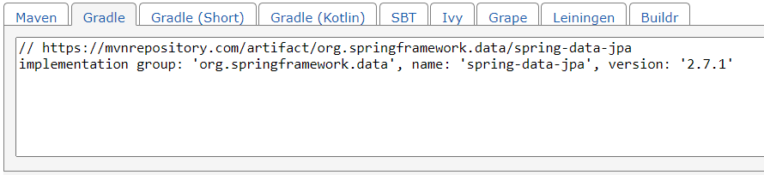

* In this task we will start our spring boot project 01 for this course. It will be a simple book info management tool.
* Get the project 01 template which is a ready to run spring boot project with gradle

1. clone project 01 repository to local:

For ssh*: git clone git@10.88.230.18:atiqur.rahman/book-info-management.git*

For http*: git clone http://10.88.230.18/atiqur.rahman/book-info-management.git*

2. fetch branches: *git fetch*

3. checkout develop branch: *git checkout "bim/develop"*

4. Set gradle and jdk in idea as follows

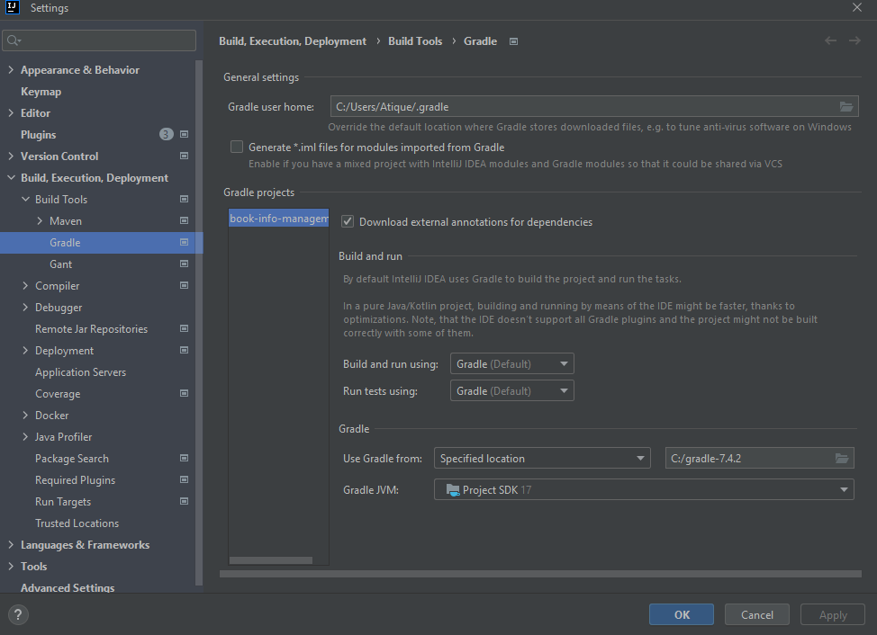

5. Sync gradle

6. create your own release branch: *git checkout -b bim/atique-202015/release-1.0*

*[Note: use your nick name and emp_id in place of “atique-202015”]*

7. create a directory named "documents" under "book-info-management" root directory like:

/*book-info-management/documents*

8. keep your task 01 doc file into this documents directory like:

*/documents/atique_202015_task_01.docx*

9. add your doc in git in the release branch: *git add .*

10. commit your changes: *git commit -m "[bim] task 01 doc upload"*

11. push you changes in release branch: *git push*

12. create feature branch for task 02 from release branch:

*git checkout -b feature/bim/atique-202015/task-02*

*[Note: use your nick name and emp_id in place of “atique-202015”]*

* You will write simple CRUD operation to keep book info in your feature branch.
* CRUD Description:

1. Create Book:

| URI | /api/v1/book |
| --- | --- |
| Desc | POST 'localhost:8084/book-info-manager-1.0/api/v1/book'  Req:  {  "id" : 1,  "bookName" : "Kobi",  "bookType" : "NOVEL",  "author" : "Humaun Ahmed"  }  Res:  {  "id" : 1,  "bookName" : "Kobi",  "bookType" : "NOVEL",  "author" : "Humaun Ahmed"  } |

1. Get Book:

| URI | /api/v1/book/{id} |
| --- | --- |
| Desc | GET 'localhost:8084/book-info-manager-1.0/api/v1/book/1'  Res:  {  "id" : 1,  "bookName" : "Kobi",  "bookType" : "NOVEL",  "author" : "Humaun Ahmed"  } |

1. Update Book:

| URI | /api/v1/book/{id} |
| --- | --- |
| Desc | PUT 'localhost:8084/book-info-manager-1.0/api/v1/book'  Req:  {  "bookName" : "Himu",  "bookType" : "NOVEL",  "author" : "Humaun Ahmed"  }  Res:  {  "id" : 1,  "bookName" : "Himu",  "bookType" : "NOVEL",  "author" : "Humaun Ahmed"  } |

1. Delete Book:

| URI | /api/v1/book/{id} |
| --- | --- |
| Desc | DELETE 'localhost:8084/book-info-manager-1.0/api/v1/book/1' |

* Create a directory named: controller

under *src/main/java/com.example.bookinfomanagement* for RestControllers

* Create a directory named: service

under *src/main/java/com.example.bookinfomanagement* for Services

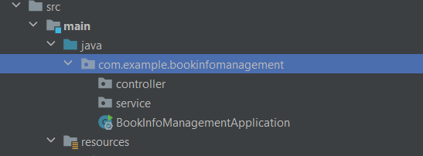

* You can use a list/map variable in your service object to store the book info for this task. No need to connect any dbms.

1. **Helper Project:**

* This is an already done project to help you.
* A simple CRUD operations to manage student info is done in this project.

1. clone helper project repository to local:

For ssh*: git clone "git@10.88.230.18:atiqur.rahman/helper-project.git"*

For http*: git clone “http://10.88.230.18/atiqur.rahman/helper-project.git”*

2. fetch branches: *git fetch*

3. checkout branch: *git checkout "hp/student-info-manage"*

* You can see the project structure and browse the code.

1. **What to submit**

* Prepare a doc/pptx with the answer of these two questions:

1. How DispatcherServlet works ?

ref: <https://www.baeldung.com/spring-dispatcherservlet>

1. How Spring MVC work ?

Ref:<https://docs.spring.io/spring-framework/docs/3.2.x/spring-framework-reference/html/mvc.html>

1. How singleton pattern work ?
2. How java bean work ?
3. Write about the dependencies we used in build.gradle
4. Why lombok ?
5. Write about the properties we used in application.properties file
6. Write about the annotations we used:

@SpringBootApplication, @RestController, @Autowired, @RequestMapping, @PostMapping, @GetMapping, @PutMapping, @DeleteMapping, @Service

* Submit your code for task 02 in gitlab. See how to submit section.

1. **How to submit**

* Name your doc/pptx as: <nick name>_<emp_id>_<task id>.

Ex: *atique_202015_task_02.docx*

* Upload your doc/pptx in documents forlder
* commit your changes in your task 02 feature branch:

*git commit -m "[bim] task 02"*

* Push the changes to your feature branch: *git push*
* Create a merge req in GitLab [feature → release]

Ex: *feature/bim/atique-202015/task-02 → bim/atique-202015/release-1.0*

* Follow up instructors feedback on GitLab on the merge request.